HOSTE D BY

Available online at [www.sciencedirect.com](http://www.sciencedirect.com/science/journal/2314808X)

ScienceDirect

journal homepage: <http://ees.elsevier.com/ejbas/default.asp>

[e gypti an j o ur nal o f b a sic and a pp l i ed sci en c e s 2 ( 201 5 ) 98](http://dx.doi.org/10.1016/j.ejbas.2015.02.003) e[109](http://dx.doi.org/10.1016/j.ejbas.2015.02.003)



Full Length Article

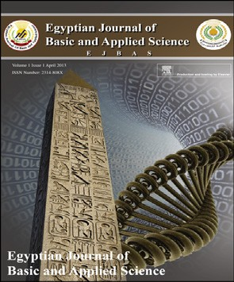Antioxidant and hepatoprotective activities of grape seeds and skin against Ehrlich solid tumor induced oxidative stress in mice



*Doaa A. Ali* *a**,*\**, Nariman K. Badr El-Din* *a**, Rania F. Abou-El-magd* *b*

a *Department of Zoology, Faculty of Science, University of Mansoura, Mansoura, Egypt*

b *Department of Medical Biology, Faculty of Medicine, Gazan University, Gazan, Saudi Arabia*

## a r t i c l e i n f o

*Article history:*

Received 26 December 2014 Received in revised form 11 February 2015

Accepted 25 February 2015

Available online 13 March 2015

*Keywords:*

Ehrlich solid tumor Oxidative stress Liver Histopathology Histochemistry Ultrastructure

## a b s t r a c t

The current study was conducted to examine the antioxidant effect of grape seeds and skin (GSE and GSK) against Ehrlich solid tumor (EST)-induced oxidative stress, hepatic dysfunction and pathological changes in the liver of albino mice. GSE and GSK were mixed with the standard diet and given to mice 14 days before subcutaneous tumor cells inocu- lation and continued for 30 days. EST-bearing mice showed increase of plasma alanine aminotransferase (ALT) and aspartate aminotransferase (AST), elevation in lipid peroxi- dation (MDA) level accompanied by a decline in glutathione (GSH), superoxide dismutase (SOD) and catalase (CAT) levels in blood and liver. Histopathologically and ultrastructur- ally, liver of EST bearing group showed hepatic degeneration with sinusoidal EST and lymphocytic infiltration, increase of collagen fibers, irregular nuclei, altered mitochondria and increase of secondary lysosomes. Histochemically, total protein and DNA contents were reduced in the liver of EST group. Conversely, GSE and GSK supplementation to EST bearing mice potentially recovered liver function enzymes, reduced MDA level, augmented antioxidant parameters, normalized liver protein and DNA contents and improved the pathologically examined hepatic lesions. In conclusion, GSE and GSK revealed potent antioxidant properties by augmenting the antioxidant defense system thereby protecting the liver against oxidative stress induced by Ehrlich solid carcinoma tumors.

Copyright 2015, Mansoura University. Production and hosting by Elsevier B.V. This is an open access article under the CC BY-NC-ND license ([http://creativecommons.org/licenses/](http://creativecommons.org/licenses/by-nc-nd/4.„0/)

[by-nc-nd/4.0/](http://creativecommons.org/licenses/by-nc-nd/4.„0/)).

# Introduction

Oxidative stress is closely related to all aspects of cancer, from carcinogenesis to the tumor-bearing state, from therapy to

prevention. The tumor-bearing state is supposed to be under oxidative stress associated with active oxygen production by tumor cells and abnormal oxidation-reduction control [1]. Several studies have indicated that tumor growth can cause antioxidant disturbances and accelerates lipid peroxidation

* *Corresponding author*. Tel.: +20 1062301308; fax: +20 502246254. E-mail address: [doaasakr@mans.edu.eg](mailto:doaasakr@mans.edu.eg) (D.A. Ali).

Peer review under responsibility of Mansoura University. <http://dx.doi.org/10.1016/j.ejbas.2015.02.003>

2314-808X/Copyright 2015, Mansoura University. Production and hosting by Elsevier B.V. This is an open access article under the CC BY- NC-ND license ([http://creativecommons.org/licenses/by-nc-nd/4.0/](http://creativecommons.org/licenses/by-nc-nd/4.„0/)).

[e gypti an j o ur nal o f b a sic a n d a pp l i ed sci en c e s 2 ( 201 5 ) 98](http://dx.doi.org/10.1016/j.ejbas.2015.02.003) e[109](http://dx.doi.org/10.1016/j.ejbas.2015.02.003) 99

(Lpx) in vital organs of the tumor hosts [2](#_bookmark11)e[4]. The use of nat- ural products is considered as one of the most effective ap- proaches of cancer treatment and was evidenced to have fewer side-effects. Dietary intake of foods rich in antioxidants was used in cancer prevention [5]. One of the most notable plants is grape, which has shown promising chemopreventive and anticancer effects in numerous *in vitro* and *in vivo* models [6,7]. Grape is one of the world's largest fruit crops and one of

the most commonly consumed antioxidants rich fruits in the

world. Grape contains a lot of active ingredients; chiefly exist in grape skin and seeds, including flavonoids, polyphenols, anthocyanins, proanthocyanidins, procyanidins, and resver- atrol [8,9]. The beneficial effects of grape seeds and skin are due to their antioxidant [10](#_bookmark17)e[12], anticancer [8,13], antimicro- bial [14], anti-inflammatory [15,16] activities and activation of apoptosis signal [14].

Our ongoing studies (not shown) indicate that GSE and GSK intake exerts a significant reduction in tumor growth of ani- mals bearing Ehrlich carcinoma. Knowledge about the effect of GSE and GSK intake on lipid peroxidation and antioxidant status has been examined in different models such as, chemical induction by DMN [9] and high fat diet [10]; however, Studies involved oxidative stress and antioxidant status in the distant organs of tumor-bearing animals are limited. There- fore, it was of particular interest to examine the antioxidant effect of GSE and GSK against Ehrlich solid tumor-induced oxidative stress in the liver of female albino mice.

# Materials and methods

### *Ehrlich ascites carcinoma cells* & *tumor induction*

Ehrlich ascites carcinoma (EAC) cells were supplied from Na- tional Cancer Institute, Cancer Biology Department, Cairo, Egypt via a 25 g female albino mouse. They were conserved by weekly intraperitoneal inoculation of saline solution con- taining 106cells/mouse [17]. Mice were inoculated subcutane-

ously with 0.2 ml of EAC, which contained 2.5 × 106 viable EAC

cells, in the back of each mouse to produce Ehrlich solid tu-

mors (EST).

### *Preparation of GSK and GSE*

from the pulps manually, GSK was dried at 50 ◦C and GSE was Grape (*Vitis vinifera*) skin (GSK) and seeds (GSE) were separated dried at 70 ◦C in a dry oven for several hours, then grinded to

powder using a grinder [9]. Equivalent amount of GSE and GSK

were mixed uniformly with the standard diet powder at con- centration of 10% (w/w) according to Shin and Moon [9].

### *Experimental design*

A total of 50 adult female Swiss albino mice weighting (18e21 g) were obtained from the animal Farm of Vacsera,

perature of 25 ± 1 ◦C with free access to drinking water and Helwan, Egypt. Animals were housed under a constant tem- acclimatized to laboratory conditions for one week prior to the

experiment. They were fed on a standard rodent diet composed of 55% corn starch, 20% casein, 15% corn oil, 5% salt

mixture and 5% vitaminized starch (Egyptian Company of Oil and Soap, Kafr Elzayat, Egypt). All experiments were carried out in accordance with the protocols approved by the Local Experimental Animal Ethics Committee. The animals were randomly divided into four groups. Group 1 (10 mice) served as untreated control (received neither EST inoculation nor GSE and GSK). Group 2 received only GSE and GSK treatment (10 mice); animals were freely fed daily the diet mixed with GSE and GSK powders at concentrations of 10% (w/w) for 44 days.

subcutaneously at the back with 2.5 × 106 EAC cells for solid Group 3 received only EST (15 mice); animals were injected tumor induction on day 14, and left without any treatment for

30 days. Group 4 received EST inoculation plus GSE and GSK (15 mice); animals were fed daily the diet mixed with GSE and GSK at concentrations of 10% (w/w) for 44 days, on day 14, they

were injected subcutaneously at the back with 2.5 × 106 EAC

cells for solid tumor induction and the diet regime was

continued for 30 days.

### *Blood sampling and biochemical investigations*

At the end of the experiment, animals were fasted for 16 h before sampling. Whole blood was collected by heart puncture after light anesthesia using heparinized syringes. The sepa- rated plasma from heparinized blood was collected and kept

at —20 ◦C until used for the determination of alanine amino-

transferase (ALT) and aspartate aminotransferase (AST)

enzyme activities colorimetrically as described by Reitman and Frankel [18], lipid peroxidation as malondialdehyde (MDA) was determined according to the colorimetric method of Yoshioka et al. [19], catalase (CAT) according to the colori- metric method of Johansson and Borg [20] and superoxide dismutase (SOD) according to the method of Minami and Yoshikawa [21]. A portion of whole blood sample was used for estimation of glutathione (GSH) according to the colorimetric method of Beutler et al. [22].

### *Liver tissue sampling for biochemical investigations*

After the collection of blood samples, all animals were killed by cervical dislocation and liver tissues were dissected out and carefully trimmed, weighed, and homogenized in potassium phosphate buffer solution (50 mM, pH 7.5) using a Potter-

nates were centrifuged at 1500 g for 10 min at 4 ◦C; superna- Elvehiem homogenizer to give a 10% homogenate. Homoge- tant was recovered, placed on ice, and immediately used for

the determination of MDA, CAT, SOD, and GSH levels by the previously mentioned methods [19](#_bookmark22)e[22].

### *Histopathological examination*

At the end of the experiment, liver sample from all different animal groups were obtained and fixed in 10% buffered neutral formalin. The fixed liver specimens were dehydrated in ascending series of ethyl alcohol and embedded in paraffin. Sections at 5 mm thickness were stained according to the following histological stains: H&E [23] and Masson's Tri-

chrome method [24] for collagen fibers.

100 [e gypti an j o ur nal o f b a sic and a pp l i ed sci en c e s 2 ( 201 5 ) 98](http://dx.doi.org/10.1016/j.ejbas.2015.02.003) e[109](http://dx.doi.org/10.1016/j.ejbas.2015.02.003)

### *Histochemical investigation*

Total protein was detected using mercury-bromophenol blue stain [25] and DNA content was investigated using Feulgen reaction [26].

### *Electron microscopic investigation*

(pH 7.2) at 4 ◦C and post-fixed in 1% cold osmium tetroxide in Dissected liver samples were fixed in 4F1G in phosphate buffer phosphate buffer at pH 7.2 for 3 h. The specimens were then

dehydrated in graded ethanol and embedded in Epson- Araldite resin. Ultrathin sections were stained by uranyl ace- tate followed by lead citrate as described by Reynolds [27] and examined on Joel Electron Microscope (JAPAN) operating at 60 kV.

### *Statistical analysis*

Values are expressed as mean ± SE (standard error). Biochemical parameters data were analyzed using one way analysis of variance followed by the bonferroni post hoc test

for multiple comparisons. A p-value ≤ 0.05 was considered

statistically significant.

# Results

### *Biochemical studies*

As shown in Fig. 1, untreated EST mice showed marked in- crease in plasma ALT& AST levels by 79.58% for ALT and 48.98% for AST as compared with the normal control group. Supplementation with GSE and GSK 14 days prior to tumor cells inoculation and throughout the experimental period, significantly inhibited the elevated levels of ALT& AST in EST bearing animals to reach 8.49%, 5.83% of control values, for ALT& AST respectively.

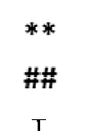

As shown in Table 1, marked elevation in MDA levels and significant inhibition of GSH content, SOD and CAT activities were observed in blood and liver of EST bearing group as compared with that of control group. In contrast, supple- mentation with GSE and GSK 14 days prior to tumor cells inoculation and throughout the experimental period signifi- cantly reduced the elevated levels of MDA in EST bearing an- imals to be comparable with the control values in blood and liver tissues. In addition, GSE and GSK supplementation restored the reduced GSH content and elevated SOD and CAT activities in blood and liver tissues to reach the normal values.

### *Histological observations*

The liver section of the control group showed the polyhedral hepatocytes with centrally located nucleus and granular cytoplasm (Fig. 2A). The hepatocytes arranged in strands alternating with blood sinusoid forming a network around central vein (Fig. 2A). Liver sections of GSE and GSK treated group showed similar structure of control liver (Fig. 2B). While liver sections of EST bearing group displayed disruption of the characteristic cord-like arrangement of the liver cells, ballooning degeneration with cytoplasmic vacuolation and intranulear cytoplasmic inclusions, sinusoidal infiltration of clumps of Ehrlich tumor cells mixed with lymphocytes and erythrocytes with associated long-lasting as shown in Fig. 2(C&D). On the other hand, liver sections of EST plus GSE and GSK treated group appeared to be normal without any tumor cell infiltration and showed a decrease in the inflam- matory cells (Fig. 2E and F). Also, the hepatocytes restored their cytoplasmic appearance and nearly normal arrangement of hepatic cords as shown in Fig. 2(E&F).

Liver tissue from the control and GSE and GSK-treated

animals revealed negligible amounts of collagen fibers around blood vessels (Fig. 3A&B). Liver sections of EST bearing group showed an increase of collagen fibers around the cen- tral veins and in the blood sinusoids (Fig. 3C). However, liver sections of EST plus GSE and GSK treated group showed

   

Fig. 1 e Effect of GSE and GSK intake on plasma ALT and AST levels of different experimental groups. Each value represents the mean ± SE of 5 mice/group, ** Significantly different from control group at 0.01 level, ##Significantly different from GSE and GSK group at 0.01 level, yy Significantly different from EST group at 0.01 level.

[e gypti an j o ur nal o f b a sic a n d a pp l i ed sci en c e s 2 ( 201 5 ) 98](http://dx.doi.org/10.1016/j.ejbas.2015.02.003) e[109](http://dx.doi.org/10.1016/j.ejbas.2015.02.003) 101

|  |  |  |  |
| --- | --- | --- | --- |
| Table 1 e Effect of GSE&GSK intake on blood & liver MDA, GSH, SOD, CAT levels of different experimental groups. | Parameters MDA GSH SOD CAT  Groups Blood Liver (mmol/gm Blood Liver (mg/gm Blood Liver (mg/gm. Blood Liver (mg/gm. (mmol/ml) wet tissue) (mg/dL) wet tissue) (mg/ml) wet tissue) (mg/ml) wet tissue) | Control 54.4 ± 4.3 175.7 ± 23.3 48.1 ± 3.8 30.2 ± 1.3 48.1 ± 1.6 334.5 ± 15.3 53.4 ± 1.7 33.9 ± 1.1  GSE&GSK 52.0 ± 1.6 172.8 ± 25.5 49.8 ± 2.9 32.3 ± 2.0 49.8 ± 2.9 335.5 ± 13.4 54.8 ± 3.3 34.6 ± 1.9  (—4.41%) (—1.67%) (3.56%) (7.00%) (3.56%) (0.3%) (2.63%) (1.77%)  EST 86.5 ± 4.4 **,## 267.0 ± 14.9 **,## 32.4 ± 1.8 **,##, 21.2 ± 0.8 **,## 37.6 ± 2.1 **,## 256.8 ± 11.2 **,## 43.5 ± 1.3 **,##,†† 26.2 ± 1.4 **,##  (59.06%) (51.94%) (—32.53%) (—29.63%) (—21.72%) (—23.20%) (—18.49%) (—22.88%)  GSE&GSK + EST 59.2 ± 3.4 †† 183.3 ± 18.9 † 44.4 ± 1.9 †† 31.2 ± 3.3 †† 44.4 ± 1.9 † 300.5 ± 10.7 † 50.6 ± 1.8 † 31.8 ± 0.9 †  (8.82%) (4.29%) (—7.62%) (3.29%) (—7.62%) (—10.20%) (—5.25%) (—6.33%) | Each value represents the mean ± SE of 5 mice/group.  **Significantly different from control group at 0.01 level.  ##Significantly different from GSE&GSK group at 0.01 level.  †,†† Significantly different from EST group at 0.05, 0.01 level respectively. (% change of control group). |

decrease of the collagen fibers particularly around the central veins and in the blood sinusoids (Fig. 3D).

### *Histochemical observations*

The protein materials in the liver cells of the control and GSE and GSK supplemented animals appeared as small bluish irregular particles which sometimes were packed closely together forming blue irregular dense bodies in the cytoplasm. The hepatocytes were limited by intensely-stained cell membranes and their nuclei contained positively stained nucleoli together with chromatin particles (Fig. 4A&B). Liver sections of EST bearing group showed reduction in total pro- tein content and most of the hepatocytes appeared with cytoplasmic vacuolation (Fig. 4C). Contrarily, liver sections of

EST + GSE and GSK treated group showed normal content of

the total protein (Fig. 4D).

DNA-containing particles in the nuclei of hepatocytes of the control and GSE and GSK treated animals appeared as red dense stained particles which were distributed in the nucle- oplasm or restricted to the peripheral rims of the nuclei (Fig. 5A&B). Also, the nuclei of kupffer cells were strongly stained. Examination of liver sections of EST bearing group showed reduction in the DNA content (Fig. 5C). In contrast, liver sections of EST plus GSE and GSK treated group showed normalization in the DNA content (Fig. 5D).

### *Ultrastructural observations*

In the present investigation, the hepatic cells of the control group display large rounded nucleus with normal distribution of euchromatin and heterochromatin. Profiles of rough endoplasmic reticulum are observed in the hepatocyte cyto- plasm especially around the nuclear envelope and in between the mitochondria (Fig. 6A). The mitochondria are numerous rounded and elongated profiles with membranous cristae and electron dense matrix (Fig. 6A). The hepatic sinusoids are lined with a discontinuous layer of endothelial cells. Microvilli of the hepatic cells are project into the lumen of the bile canaliculi and in the space of Disse (Fig. 6B&C). The hepatic cells, bile canaliculi and blood sinusoids of GSE and GSK supplemented animals seem to be normal as those of the control group (Fig. 6DeF). In contrast, the liver tissue of EST- bearing mice showed ultrastructural alterations including irregular nuclei with lipid droplets inclusion (Fig. 7A). In addition, mitochondria were packed close to each other. Some were large, some were small and others appeared to be branching or budding (Fig. 7A&C). Moreover, lipid droplets, glycogen particles and large number of secondary lysosomes and microbodies were obviously seen in most of the cells (Fig. 7B&C). The hepatocytes became swollen and lost their cytoplasmic density (Fig. 7B&C). In addition, the blood sinu- soid was wide and discontinues with destructed endothelial cells and detachment of kupffer cells (Fig. 7C) However, the liver tissue of EST plus GSE and GSK exhibit remarkable im- provements. The nuclei of the hepatic cells were more or less similar to those of control (Fig. 7E). The mitochondria and smooth ER were prominent in the cytoplasm of these cells in a healthy appearance and the lipid droplets were mostly dis- appeared (Fig. 7D&E). The bile canaliculi and blood sinusoid

102 [e gypti an j o ur nal o f b a sic and a pp l i ed sci en c e s 2 ( 201 5 ) 98](http://dx.doi.org/10.1016/j.ejbas.2015.02.003) e[109](http://dx.doi.org/10.1016/j.ejbas.2015.02.003)

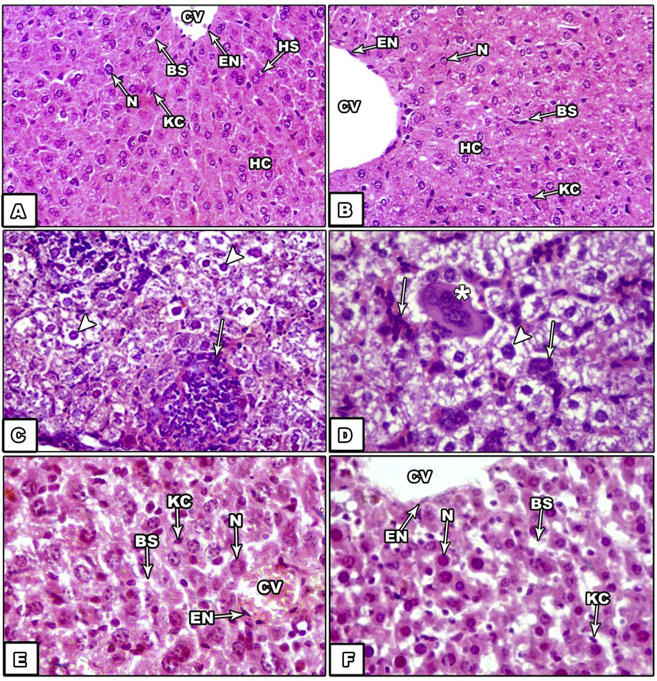

Fig. 2 e Liver histopathology of EST bearing mice and/or treated with GSE and GSK. Liver section of control mice (A) showing normal histological appearance of liver including central vein (CV), blood sinusoids (BS), hepatic cells (HC), Kupffer cell (KC) and centrally located nuclei (N) (H&E, X250), liver section of GSE and GSK treated group (B) showing no remarkable changes (H&E, X250), liver sections of EST bearing mice (C&D) illustrating sinusoidal infiltration of carcinoma cells mixed with lymphocytes (arrows), the hepatocytes have clear to foamy cytoplasm with intranulear inclusions (arrowheads) (H&E, X400), liver section of EST plus GSE and GSK treated group (E&F) displaying no tumor cell invasion, few lymphocytic infiltration (LI) and nearly normal arrangement of hepatic cords (H&E, X400).

were quite normal with respect to that of control group (Fig. 7E&F).

# Discussion

In the present work, untreated EST bearing mice showed sig- nificant elevation in plasma ALT and AST levels as compared with that of control group. These data indicate that the development of tumor in the animal body can affect many functions of vital organs such as liver function. These results correlated well with Gupta et al. [28] who recorded elevation of liver transaminases in EAC bearing mice indicating liver dysfunction. Conversely, EST plus GSE and GSK group showed significant decrease in plasma levels of ALT and AST to reach the normal values. These results suggest that grape skin and

seed supplementation protects the hepatocytes from injuries and improves the liver functions of EST bearing mice. These findings are in agreement with the study of Shin and Moon [9] who found that grape skin & seeds mixed with normal food to rat, significantly inhibited the elevated levels of serum AST & ALT due to dimethylnitrosamine (DMN)-induced liver injury. Malondialdehyde (MDA) the end product of lipid peroxi- dation acts as a marker of oxidative stress [10,29]. In the cur- rent study, EST bearing mice displayed significant increase in blood and liver MDA content. Previous studies demonstrated that tumor growth disrupts the antioxidant system and in- creases LPx in tumor host vital organs [2](#_bookmark11)e[4]. The generation of lipid peroxide and its increase in the mouse liver could result from a chain reaction or could be initiated by indirect mech- anisms that have escaped the antioxidant capacity of the liver

of EST bearing mice [3].

[e gypti an j o ur nal o f b a sic a n d a pp l i ed sci en c e s 2 ( 201 5 ) 98](http://dx.doi.org/10.1016/j.ejbas.2015.02.003) e[109](http://dx.doi.org/10.1016/j.ejbas.2015.02.003) 103

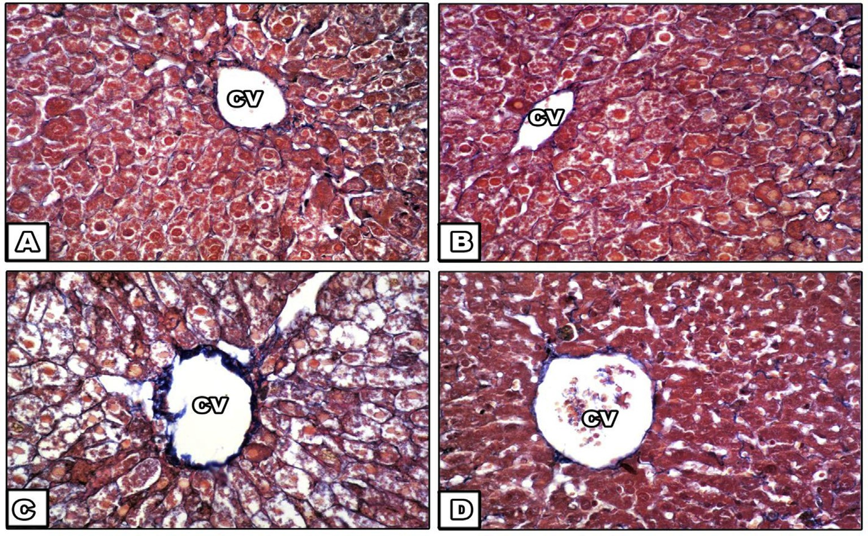

Fig. 3 e Liver histology of EST bearing mice and/or treated with GSE and GSK demonstrating the collagen fibers. Liver section of control mice (A) illustrating negligible amount of collagen fibers around the central vein (CV), liver section of GSE and GSK treated mice (B) showing no remarkable changes, liver sections of EST bearing mice (C) illustrating large amount of collagen fibers around central vein (CV), liver section of EST plus GSE and GSK treated group (D) showing decrease in the amount of collagen fibers around the central vein (CV) (Masson trichrome stain, X400).

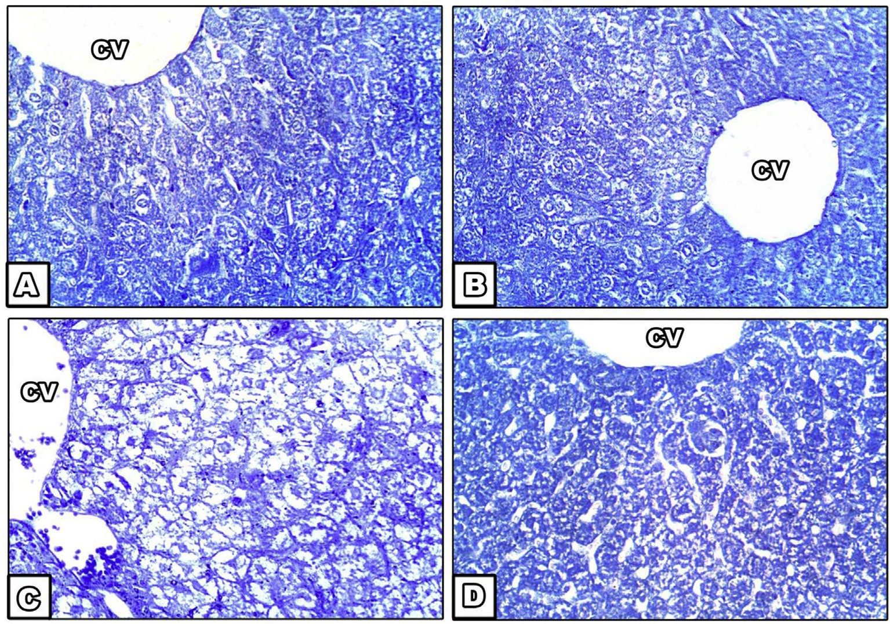

Fig. 4 e Liver histochemical demonstration of the content and localization of total proteins of EST bearing mice and/or treated with GSE and GSK. Liver section of control mice (A) showing normal dense protein content with normal distribution of protein in all of the hepatocytes, liver section of GSE and GSK treated mice (B), liver sections of EST bearing mice (C) displaying reduction of total protein content, liver section of EST plus GSE and GSK treated group (D) illustrating normalization of total protein (Bromophenol blue stain, X400).

104 [e gypti an j o ur nal o f b a sic and a pp l i ed sci en c e s 2 ( 201 5 ) 98](http://dx.doi.org/10.1016/j.ejbas.2015.02.003) e[109](http://dx.doi.org/10.1016/j.ejbas.2015.02.003)

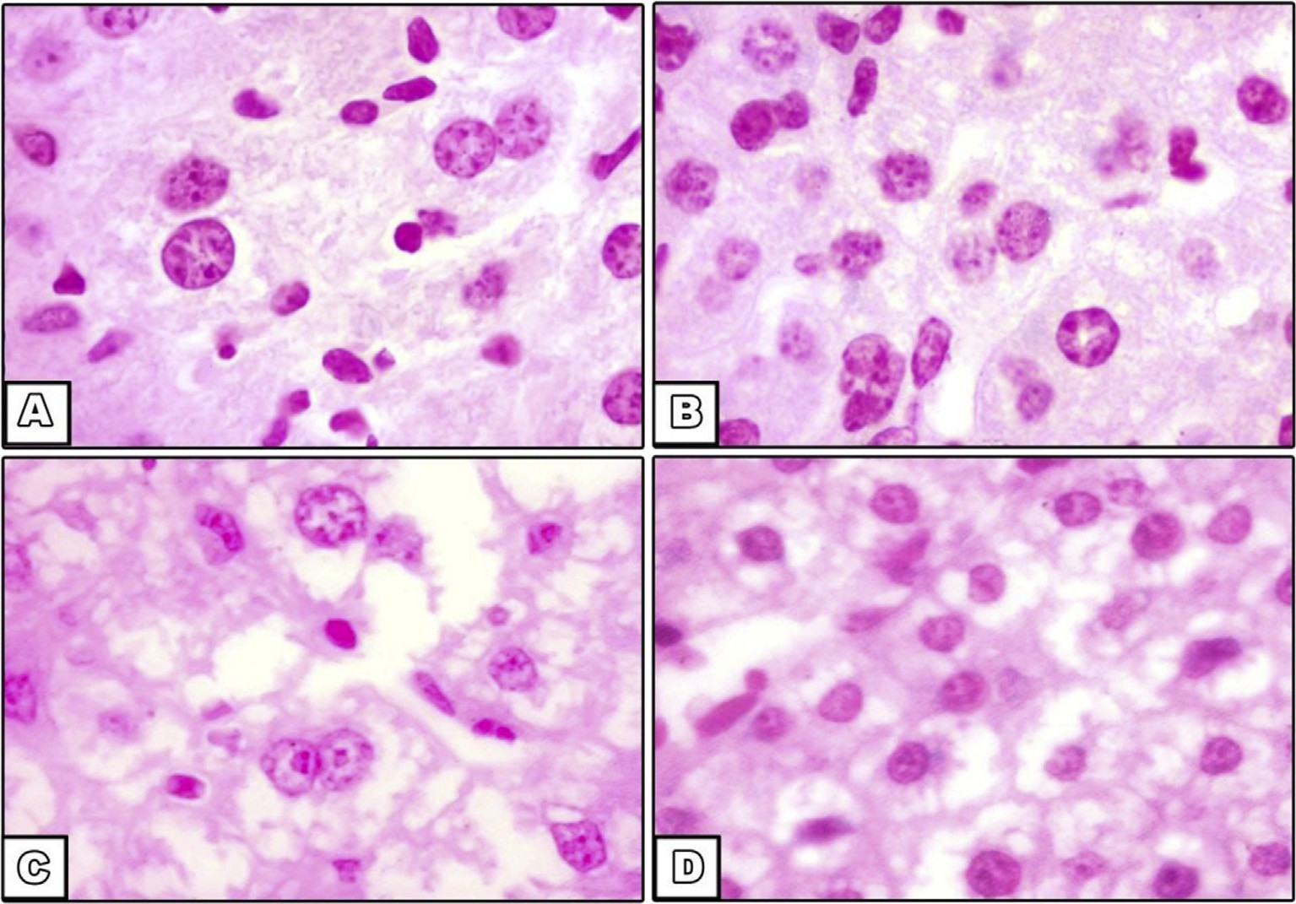

Fig. 5 e Liver histochemical demonstration of the DNA content of EST bearing mice and/or treated with GSE&GSK. Liver section of control mice (A) and GSE and GSK treated mice (B) showing normal DNA-containing particles (C) Section in liver of mice bearing EST showed reduction in DNA content. (D) Section in liver of mice bearing EST treated by GSE and GSK showed normalization of DNA content (Feulgen, X400).

The present data reveal marked depletion in GSH content of blood and liver of EST bearing mice accompanied by sig- nificant inhibition of SOD and catalase activities. There is a close correlation between depletion of GSH and antioxidant enzymes and the increase in LPx [30]. GSH plays an important role as an endogenous antioxidant system that is found particularly in high concentration in liver and is known to have key function in protecting cells by scavenging ROS [31,32], modulating cellular redox status and acting as a cofactor for antioxidant enzymes [29,33,34]. On the other hand, the free radical scavenging system, CAT and SOD are to provide a guard against the potentially injurious reactivity of superoxide and hydrogen peroxide [35](#_bookmark35)e[37]. Level of GSH and antioxidant status during tumor growth was previously investigated by Navarro et al. [38]. Their study showed a reduction in blood glutathione redox (GSH/GSSG) in Ehrlich ascites carcinoma ebearing mice. They attributed this result to the oxidative stress that caused an elevation in peroxide formation by cancer cells. GSH oxidation occurred in the red blood cells leads to the release of GSSG from the different tissues to the blood stream [38,39].

Significant reduction in SOD and catalase levels in blood

and liver tissue of tumor-bearing mice was detected in the present study. SOD activity was also found to decline in Ehr- lich ascites carcinoma-bearing mice as reported by others [40]. They reported that such decline could be due to a loss of mitochondria that may lead to a reduction in SOD level in several tissue of the tumor-bearing animal. Similar results of SOD activity were detected by Abu-Zeid et al. [41] in plasma, lung and liver of Ehrlich carcinoma-bearing animals. It is

worth mention that tumor development may lead to the degradation of antioxidant enzymes such as SOD and catalase as a result of uncontrolled oxidative damage [42].

The current study revealed that GSE & GSK intake reduced the elevated levels of LPx and increased GSH, SOD and CAT activities in EST bearing mice, which may indicate the possible antioxidant and free radical scavenging property of GSE and GSK supplementation. These results are in agree- ment with Chis et al. [43], Al-Sowayan and Kishore [44] and Leifert and Abeywardena [45] who reported that oral admin- istration of proanthocyanidin extract improved SOD and CAT levels and reduced the levels of lipid peroxides and enhanced the antioxidant defense against reactive oxygen species pro- duced under Doxorubicin treatment, thereby protecting liver cells. These results were supposedly caused by supplemen- tation with grape seeds & skin that considered as a rich source of polyphenols, which have numerous beneficial effects on oxidative stress and protect cells and tissues from oxidative damage that could be due to their strong antioxidant activities of scavenging reactive oxygen [29].

In the present investigation, liver sections of EST bearing

mice displayed hepatocyte cytoplasmic vacuolation with intranulear cytoplasmic inclusions and clumps of Ehrlich tumor cells mixed with lymphocytes and erythrocytes. Confirmation of the present result comes from previous studies [46](#_bookmark43)e[48]. Ehrlich tumor cells infiltrations may be due to the tumor cells proliferate and migrate into the internal or- gans [17,49]. Aggregations of inflammatory cells may be due to degeneration of the mitochondria or disorganization of the cytoplasm [50]. Ballooning degeneration of hepatocytes

[e gypti an j o ur nal o f b a sic a n d a pp l i ed sci en c e s 2 ( 201 5 ) 98](http://dx.doi.org/10.1016/j.ejbas.2015.02.003) e[109](http://dx.doi.org/10.1016/j.ejbas.2015.02.003) 105

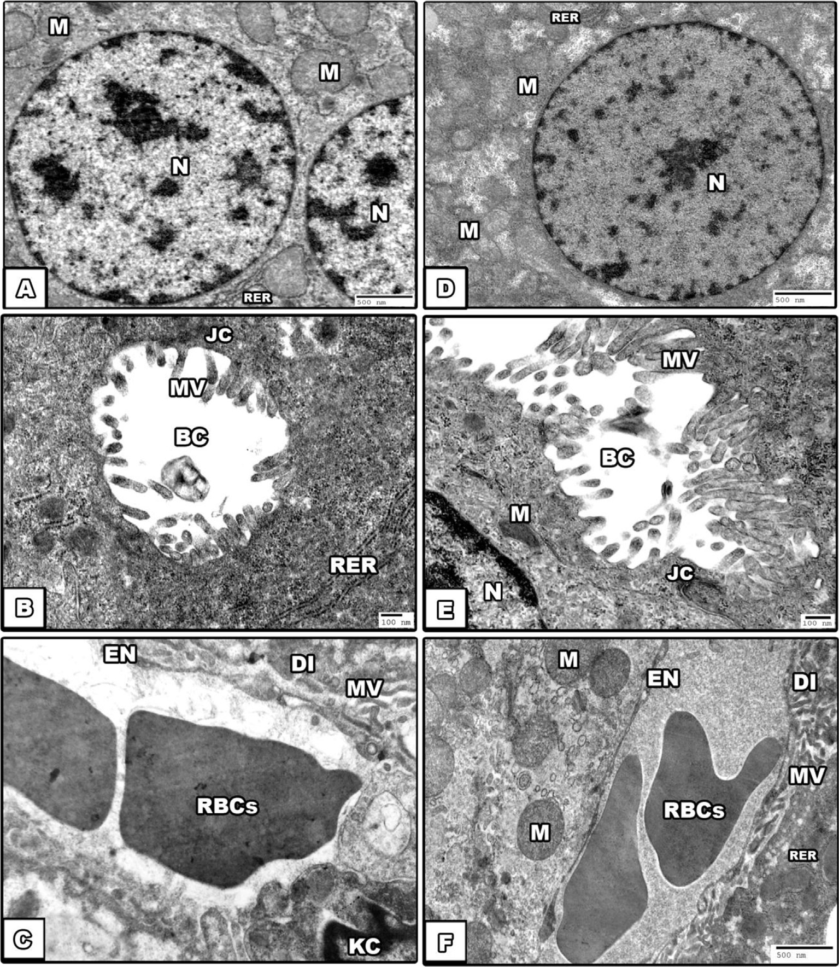

Fig. 6 e Electron photomicrograph of liver of control mice (AeC), illustrating the hepatocytes with normal large rounded nucleus (N), rough endoplasmic reticulum (RER) and mitochondria (M), normal blood sinusoids with endothelial lining cells (EN), wide space of Disse (DI), Kupffer cell (KC) and red blood cells (RBCs). Microvilli (MV) are project into the bile canaliculi (BC) which secured with the junctional complex (JC) and in the space of Disse (DI). The liver of GSE and GSK treated animals are quite normal as those described of the control group (DeF).

supposed to be caused by lysosomal enzymes and hydration [51], as evidenced in the present ultrastructural observations. In contrast, liver sections of EST plus GSE and GSK treated group showed nearly normal construction of hepatic lobules with few altered hepatic cells. Neither inflammatory cells nor Ehrlich cells could be detected and this result are agree with Sun et al. [52] who showed that grape polyphenols dietary supplementation prevented the liver injury induced by ethanol. Also, Kasdallah-Grissa et al. [53] found that resvera- trol reduced hepatic tissue injury. In addition, oral intake of grape seeds attenuated histopathological changes caused by tamoxifen in the liver of rats [54]. Moreover, another study demonstrated that grape polyphenols, including resveratrol, epicatechin, and epigallocatechin, can inhibit cancer cell

invasion [55]. This can be considered as functional improve- ment of hepatocytes, which might be due to accelerated regeneration of parenchymal cells or limited damage in the presence of GSE&GSK supplementation. Also, the current study showed that GSE and GSK intake to normal mice did not produce any detectable structural changes in the liver tissues. Liver sections of EST bearing mice in this study showed increased collagen fibers around the central veins. Horn et al.

1. declared that the presence of collagen in the peri- sinusoidal space might affect the blood supply to liver cells and would reduce the exchange of metabolites, perhaps causing hepatocellular dysfunction and necrosis. Enzan et al.
2. and Foo et al. [58] attributed this finding to the activation of hepatic stellate cells. George et al. [59] contribute the

106 [e gypti an j o ur nal o f b a sic and a pp l i ed sci en c e s 2 ( 201 5 ) 98](http://dx.doi.org/10.1016/j.ejbas.2015.02.003) e[109](http://dx.doi.org/10.1016/j.ejbas.2015.02.003)

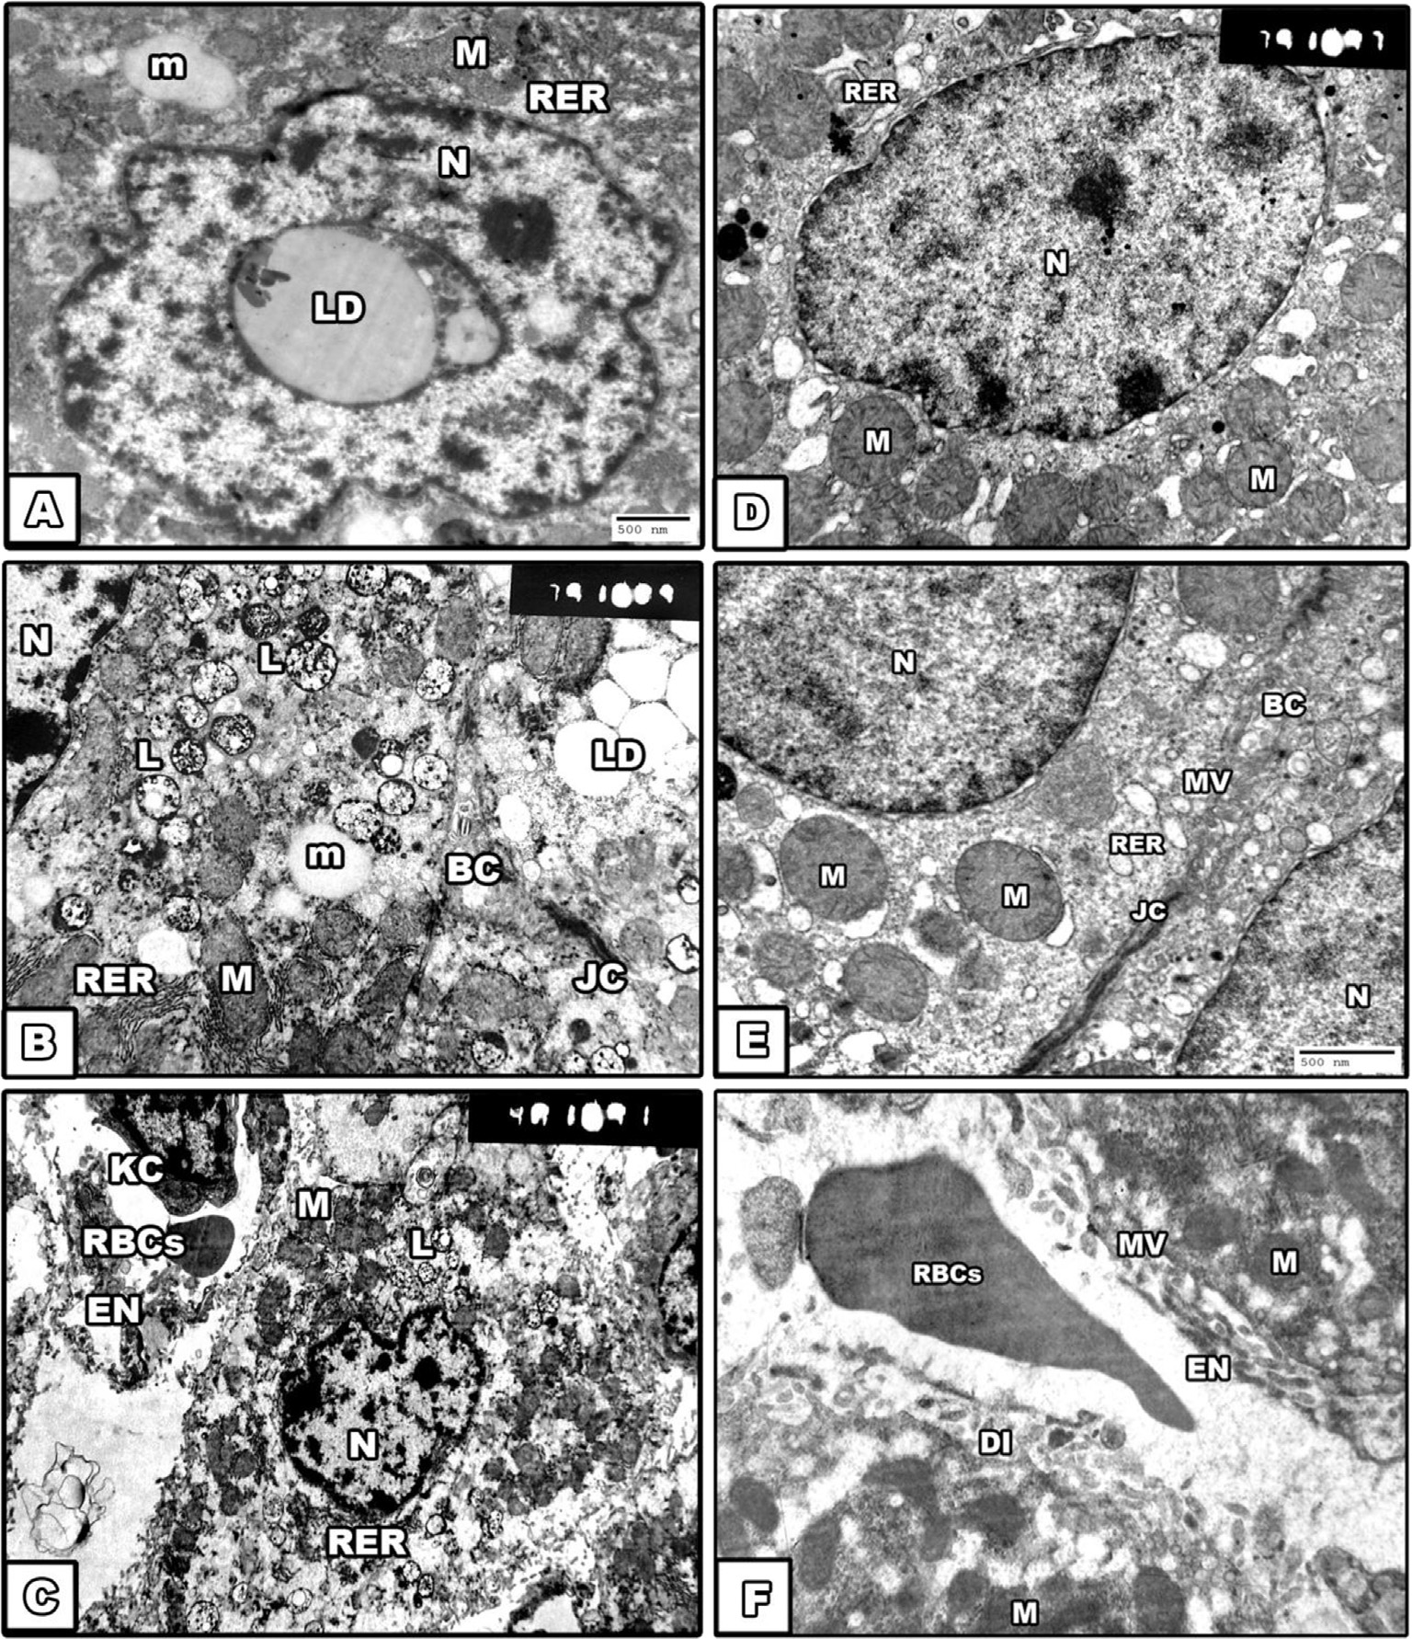

Fig. 7 e Electron photomicrograph of hepatocytes of EST bearing mice (AeC) showed ultrastructural alterations. The nuclei

(N) were irregular with lipid droplets inclusion. Moreover, lipid droplets (LD), glycogen particles and large number of secondary lysosomes (L) and microbodies (m) were seen in most of the cells, the bile canaliculi (BC) were less similar to those of control group, blood sinusoid was wide with destructed endothelial cells (EN) and detachment of kupffer cells (KC). The liver tissue of EST plus GSE and GSK treated group (DeF) exhibit remarkable improvements.

accumulation of collagen to the decreased synthesis of colla- genolytic enzymes by the damaged hepatocytes. The presence of fibrosis suggests more advanced and severe liver injury [60]. Oxidative stress, in particular lipid peroxidation, induces collagen synthesis [61], as demonstrated in the present study. While GSE and GSK supplementation to EST bearing mice significantly reduced the collagen deposition in the liver tis- sue. These findings suggest that GSE and GSK have an addi- tional protective effect against oxidant-induced production and deposition of extracellular matrix components.

Histochemically, liver sections of EST bearing group in the current study showed reduction in total proteins and DNA contents. Likewise, El-Banhawy et al. [62] indicated existence of a close parallelism between nucleic acids and the level of

protein synthesis, thereby; this reduction in the protein and DNA contents could be attributed to the nuclear pathological changes which were evidenced in the present work as well as in previous studies [17,48,63]. Similarly, Salem et al. [64] showed a significant decrease in total protein and albumin level in EAC bearing mice. They attributed these results to an increase in mitotic division of neoplastic cells with high bloody fluid withdrawal and capillary permeability which enable the escape of plasma proteins into the peritoneal cavity and it may also be due to hepatic cell necrosis [65]. In addition, total proteins may decrease in animals with liver disease [66]. DNA damage has been also reported in tissues proximal and distant from non-metastasizing implanted tu- mors in mice due to inflammation and oxidative stress [67]. In

[e gypti an j o ur nal o f b a sic a n d a pp l i ed sci en c e s 2 ( 201 5 ) 98](http://dx.doi.org/10.1016/j.ejbas.2015.02.003) e[109](http://dx.doi.org/10.1016/j.ejbas.2015.02.003) 107

contrast, liver sections of EST plus GSE and GSK treated group

## references

showed normalization of the total protein and DNA contents.

Previous studies [68,69] demonstrated that proanthocyanidin

provides significantly greater protection against biochemical changes, free radicals, lipid peroxidation and DNA damage. In addition, its presumed contribution to DNA repair may be another important attribute, which plays a role in grape pro- tective effects [44].

In the present ultrastructural findings, the liver tissue of EST bearing mice showed irregular nuclei with lipid droplets inclusion. Such result goes parallel with the previous results obtained by other investigators in benign and malignant tu- mors [70](#_bookmark62)e[72]. Intranuclear inclusions are in fact nuclear in- vaginations by cytoplasm. It has been suggested that these inclusions may also be formed by cytoplasmic contents being forced into the nucleus during mitosis [73] as evidenced by observation of lipid droplets in the nucleus in the present study. Rose [74] made similar observations and nicely depic- ted the formation of intranuclear pseudoinclusions in cells from cultures of human melanoma, osteogenic sarcoma and other tumors. In many of these pseudoinclusions, the double nuclear membrane may not be seen, possibly because of the degeneration and subsequent disintegration of the outer membrane [72,74]. In addition, mitochondria were packed close to each other; some were large, some were small and other appeared to be branching or budding. Such results are confirmed through the work of previous studies [72]. This mitochondrial pleomorphism has been observed in states of iron deficiency [75] and in both hypoxia and hyperoxia [76], which may represent the direct toxic effect of tumor on the liver. Also, large number of secondary lysosomes was obvi- ously seen in many cells. Our findings are in accordance with Ghadially and Parry [77] and Parry and Ghadially [78,79] who observed a marked increase in lysosomes in the livers of tumor bearing animals. According to Telbisz et al. [80] and Abd El-Wahab and Fouda [17], activation of autophagy is frequently observed in different degenerated tissues. Lyso- somal enzymes discharges have a key role in the induction of necrotic changes. On the contrary, the liver tissue of EST plus GSE and GSK group exhibited remarkable improvements. The nuclei of the hepatic cells were more or less similar to those of control. The mitochondria and smooth ER were prominent in a healthy appearance and the lipid droplets were mostly dis- appeared. The bile canaliculi and blood sinusoid seemed to be normal with respect to that of EST bearing group. Thus, the dietary supplementation of GSE and GSK to EST bearing mice exhibited significant ameliorative potential probably by attenuating the tumor-mediated oxidative stress and preser- ving the structural and functional integrity of hepatocytes.

# Conclusions

In conclusion, the present study confirmed that grape skin and seeds treated animals exhibited *in vivo* hepatoprotective and antioxidant effects against liver injury induced by Ehrlich solid tumor growth. The mechanism appeared mostly to be mediated by counteracting free radicals thereby reducing oxidative stress and augmenting antioxidants in Ehrlich solid tumor-bearing mice.

1. [Noda N, Wakasugi H. Cancer and oxidative stress. Jpn Med](http://refhub.elsevier.com/S2314-808X(15)00016-0/sref1) [Assoc J 2001;44(12):535](http://refhub.elsevier.com/S2314-808X(15)00016-0/sref1)e[9](http://refhub.elsevier.com/S2314-808X(15)00016-0/sref1).
2. [Gonenc A, Ozkan Y, Torun M, Simsek B. Plasma](http://refhub.elsevier.com/S2314-808X(15)00016-0/sref2) [malondialdehyde (MDA) levels in breast and lung cancer](http://refhub.elsevier.com/S2314-808X(15)00016-0/sref2) [patients. J Clin Pharm Ther 2001;26:141](http://refhub.elsevier.com/S2314-808X(15)00016-0/sref2)e[4](http://refhub.elsevier.com/S2314-808X(15)00016-0/sref2).
3. [Badr El-Din NK. Protective role of sanumgerman against g](http://refhub.elsevier.com/S2314-808X(15)00016-0/sref3) [irradiation](http://refhub.elsevier.com/S2314-808X(15)00016-0/sref3)e [induced oxidative stress in Ehrlich carcinoma-](http://refhub.elsevier.com/S2314-808X(15)00016-0/sref3) [bearing mice. Nutr Res 2004;24:271](http://refhub.elsevier.com/S2314-808X(15)00016-0/sref3)e[91](http://refhub.elsevier.com/S2314-808X(15)00016-0/sref3).
4. [Noaman E, Badr El-Din NK, Bibars MA, Abou Mossallam AA,](http://refhub.elsevier.com/S2314-808X(15)00016-0/sref4) [Ghoneum M. Antioxidant potential by arabinoxylan rice](http://refhub.elsevier.com/S2314-808X(15)00016-0/sref4) [bran, MGN-3/biobran, represents a mechanism for its](http://refhub.elsevier.com/S2314-808X(15)00016-0/sref4) [oncostatic effect against murine solid Ehrlich carcinoma.](http://refhub.elsevier.com/S2314-808X(15)00016-0/sref4) [Cancer Lett 2008;268(2):348](http://refhub.elsevier.com/S2314-808X(15)00016-0/sref4)e[59](http://refhub.elsevier.com/S2314-808X(15)00016-0/sref4).
5. [Kelkel M, Schumacher M, Dicato M, Diederich M. Antioxidant](http://refhub.elsevier.com/S2314-808X(15)00016-0/sref5) [and anti-proliferative properties of lycopene. Free Radic Res](http://refhub.elsevier.com/S2314-808X(15)00016-0/sref5) [2011;45(8):925](http://refhub.elsevier.com/S2314-808X(15)00016-0/sref5)e[40](http://refhub.elsevier.com/S2314-808X(15)00016-0/sref5).
6. [Lee CK, Park KK, Lim SS, Park JHY, Chung WY. Effects of](http://refhub.elsevier.com/S2314-808X(15)00016-0/sref6) [licorice extract against tumor growth and cisplatin induced](http://refhub.elsevier.com/S2314-808X(15)00016-0/sref6) [toxicity in a mouse xenograft model of colon cancer. Biol](http://refhub.elsevier.com/S2314-808X(15)00016-0/sref6) [Pharm Bull 2007;30(11):2191](http://refhub.elsevier.com/S2314-808X(15)00016-0/sref6).
7. [Yang CS, Wang H. Mechanistic issues concerning cancer](http://refhub.elsevier.com/S2314-808X(15)00016-0/sref7) [prevention by tea catechins. Mol Nutr Food Res](http://refhub.elsevier.com/S2314-808X(15)00016-0/sref7) [2011;55(6):819](http://refhub.elsevier.com/S2314-808X(15)00016-0/sref7)e[31](http://refhub.elsevier.com/S2314-808X(15)00016-0/sref7).
8. [Lazze MC, Pizzala R, Pecharroman FJG, Garnica PG,](http://refhub.elsevier.com/S2314-808X(15)00016-0/sref8) [Rodriguez JMA, Fabris N, et al. Grape waste extract obtained](http://refhub.elsevier.com/S2314-808X(15)00016-0/sref8) [by supercritical fluid extraction contains bioactive](http://refhub.elsevier.com/S2314-808X(15)00016-0/sref8) [antioxidant molecules and induces antiproliferative effects](http://refhub.elsevier.com/S2314-808X(15)00016-0/sref8) [in human colon adenocarcinoma cells. J Med Food](http://refhub.elsevier.com/S2314-808X(15)00016-0/sref8) [2009;12:561](http://refhub.elsevier.com/S2314-808X(15)00016-0/sref8)e[8](http://refhub.elsevier.com/S2314-808X(15)00016-0/sref8).
9. [Shin M, Moon J. Effect of dietary supplementation of grape](http://refhub.elsevier.com/S2314-808X(15)00016-0/sref9) [skin and seeds on liver fibrosis induced by](http://refhub.elsevier.com/S2314-808X(15)00016-0/sref9) [dimethylnitrosamine in rats. Nutr Res Prac 2010;4(5):369](http://refhub.elsevier.com/S2314-808X(15)00016-0/sref9)e[74](http://refhub.elsevier.com/S2314-808X(15)00016-0/sref9).
10. [Choi SK, Zhang XH, Seo JS. Suppression of oxidative stress by](http://refhub.elsevier.com/S2314-808X(15)00016-0/sref10) [grape seed supplementation in rats. Nutr Res Prac](http://refhub.elsevier.com/S2314-808X(15)00016-0/sref10) [2012;6:3](http://refhub.elsevier.com/S2314-808X(15)00016-0/sref10)e[8](http://refhub.elsevier.com/S2314-808X(15)00016-0/sref10).
11. [Da Costa LA, Badawi A, El-Sohemy A. Nutrigenetics and](http://refhub.elsevier.com/S2314-808X(15)00016-0/sref11) [modulation of oxidative stress. Ann Nutr Metab](http://refhub.elsevier.com/S2314-808X(15)00016-0/sref11) [2012;60:27](http://refhub.elsevier.com/S2314-808X(15)00016-0/sref11)e[36](http://refhub.elsevier.com/S2314-808X(15)00016-0/sref11).
12. [Callaghan CM, Leggett RE, Levin RM. A comparison of total](http://refhub.elsevier.com/S2314-808X(15)00016-0/sref12) [antioxidant capacities of concord, purple, red, and green](http://refhub.elsevier.com/S2314-808X(15)00016-0/sref12) [grapes using the CUPRAC assay. Antioxidants 2013;2:257](http://refhub.elsevier.com/S2314-808X(15)00016-0/sref12)e[64](http://refhub.elsevier.com/S2314-808X(15)00016-0/sref12).
13. [Hudson TS, Hartle DK, Hursting SD, Nunez NP, Wang TTY,](http://refhub.elsevier.com/S2314-808X(15)00016-0/sref13) [Young HA, et al. Inhibition of prostate cancer growth by](http://refhub.elsevier.com/S2314-808X(15)00016-0/sref13) [muscadine grape skin extract and resveratrol through](http://refhub.elsevier.com/S2314-808X(15)00016-0/sref13) [distinct mechanisms. Cancer Res 2007;67:8396](http://refhub.elsevier.com/S2314-808X(15)00016-0/sref13)e[405](http://refhub.elsevier.com/S2314-808X(15)00016-0/sref13).
14. [Yadav M, Jain S, Bhardwaj A, Nagpal R, Puniya M, Tomar R,](http://refhub.elsevier.com/S2314-808X(15)00016-0/sref14) [et al. Biological and medicinal properties of grapes and their](http://refhub.elsevier.com/S2314-808X(15)00016-0/sref14) [bioactive constituents. J Med Food 2009;12(3):473](http://refhub.elsevier.com/S2314-808X(15)00016-0/sref14)e[84](http://refhub.elsevier.com/S2314-808X(15)00016-0/sref14).
15. [Chacon MR, Ceperuelo-Mallafre V, Maymo-Masip E, Mateo-](http://refhub.elsevier.com/S2314-808X(15)00016-0/sref15) [Sanz JM, Arola L, Guitierrez C, et al. Grape-seed procyanidins](http://refhub.elsevier.com/S2314-808X(15)00016-0/sref15) [modulate inflammation on human differentiated adipocytes](http://refhub.elsevier.com/S2314-808X(15)00016-0/sref15) [*in vitro*. Cytokine 2009;47:137](http://refhub.elsevier.com/S2314-808X(15)00016-0/sref15)e[42](http://refhub.elsevier.com/S2314-808X(15)00016-0/sref15).
16. [Panico AM, Cardile V, Avondo S, Garufi F, Gentile B, Puglia C,](http://refhub.elsevier.com/S2314-808X(15)00016-0/sref16) [et al. The *in vitro* effect of a lyophilized extract of wine](http://refhub.elsevier.com/S2314-808X(15)00016-0/sref16) [obtained from jacquez grapes on human chondrocytes.](http://refhub.elsevier.com/S2314-808X(15)00016-0/sref16) [Phytomedicine 2006;13:522](http://refhub.elsevier.com/S2314-808X(15)00016-0/sref16)e[6](http://refhub.elsevier.com/S2314-808X(15)00016-0/sref16).
17. [Abd El-Wahab SM, Fouda FM. Histological and histochemical](http://refhub.elsevier.com/S2314-808X(15)00016-0/sref17) [study on the effect of Ehrlich ascites carcinoma on the liver](http://refhub.elsevier.com/S2314-808X(15)00016-0/sref17) [and kidney of mice and the possible protective role of](http://refhub.elsevier.com/S2314-808X(15)00016-0/sref17) [tetrodotoxin. Egy J Biol 2009;11:13](http://refhub.elsevier.com/S2314-808X(15)00016-0/sref17)e[25](http://refhub.elsevier.com/S2314-808X(15)00016-0/sref17).
18. [Reitman S, Frankel S. A colorimetric method for the](http://refhub.elsevier.com/S2314-808X(15)00016-0/sref18) [determination of serum glutamic oxaloacetic and glutamic](http://refhub.elsevier.com/S2314-808X(15)00016-0/sref18) [pyruvic transaminases. Am J Clin Pathol 1957;28:56](http://refhub.elsevier.com/S2314-808X(15)00016-0/sref18)e[63](http://refhub.elsevier.com/S2314-808X(15)00016-0/sref18).
19. [Yoshioka T, Kawada K, Shimada T, Mori M. Lipid](http://refhub.elsevier.com/S2314-808X(15)00016-0/sref19) [peroxidation in maternal and cord blood and protective](http://refhub.elsevier.com/S2314-808X(15)00016-0/sref19)

108 [e gypti an j o ur nal o f b a sic and a pp l i ed sci en c e s 2 ( 201 5 ) 98](http://dx.doi.org/10.1016/j.ejbas.2015.02.003) e[109](http://dx.doi.org/10.1016/j.ejbas.2015.02.003)

[mechanism against activated oxygen toxicity in the blood.](http://refhub.elsevier.com/S2314-808X(15)00016-0/sref19) [Am J Obstet Gynecol 1979;135:372](http://refhub.elsevier.com/S2314-808X(15)00016-0/sref19)e[6](http://refhub.elsevier.com/S2314-808X(15)00016-0/sref19).

1. [Johansson LH, Borg LAH. A spectrophotometric method for](http://refhub.elsevier.com/S2314-808X(15)00016-0/sref20) [determination of catalase activity in small tissue sample.](http://refhub.elsevier.com/S2314-808X(15)00016-0/sref20) [Anal Biochem 1988;174:331](http://refhub.elsevier.com/S2314-808X(15)00016-0/sref20)e[6](http://refhub.elsevier.com/S2314-808X(15)00016-0/sref20).
2. [Minami M, Yoshikawa H. A simplified assay method of](http://refhub.elsevier.com/S2314-808X(15)00016-0/sref21) [superoxide dismutase activity for clinical use. Clin Chim](http://refhub.elsevier.com/S2314-808X(15)00016-0/sref21) [Acta 1979;92:337](http://refhub.elsevier.com/S2314-808X(15)00016-0/sref21)e[42](http://refhub.elsevier.com/S2314-808X(15)00016-0/sref21).
3. [Beutler E, Duron O, Kelly BM. Improved method of the](http://refhub.elsevier.com/S2314-808X(15)00016-0/sref22) [determination of blood glutathione. J Lab Clin Med](http://refhub.elsevier.com/S2314-808X(15)00016-0/sref22) [1963;61:882](http://refhub.elsevier.com/S2314-808X(15)00016-0/sref22)e[8](http://refhub.elsevier.com/S2314-808X(15)00016-0/sref22).
4. [Weesner FM. General zoological microtechniques. Calcutta:](http://refhub.elsevier.com/S2314-808X(15)00016-0/sref23) [Scientific Book Agency; 1968](http://refhub.elsevier.com/S2314-808X(15)00016-0/sref23).
5. [Masson PJ. AFIP modification. J Tech Methods 1929;12:75](http://refhub.elsevier.com/S2314-808X(15)00016-0/sref24)e[90](http://refhub.elsevier.com/S2314-808X(15)00016-0/sref24).
6. [Mazia D, Brewer PA, Affert M. The cytochemical staining and](http://refhub.elsevier.com/S2314-808X(15)00016-0/sref25) [measurements of protein with mercuric bromophenol blue.](http://refhub.elsevier.com/S2314-808X(15)00016-0/sref25) [Biol Bull 1953;104:57](http://refhub.elsevier.com/S2314-808X(15)00016-0/sref25)e[67](http://refhub.elsevier.com/S2314-808X(15)00016-0/sref25).
7. [Pearse AGE. Histochemistry, theoretical and applied. 4th ed.,](http://refhub.elsevier.com/S2314-808X(15)00016-0/sref26) [vol. 2. London: Churchill, Ltd.; 1985](http://refhub.elsevier.com/S2314-808X(15)00016-0/sref26).
8. [Reynolds ES. The use of lead citrate at high pH as an electron](http://refhub.elsevier.com/S2314-808X(15)00016-0/sref27) [microscopy. J Cell Biol 1963;17:208](http://refhub.elsevier.com/S2314-808X(15)00016-0/sref27)e[12](http://refhub.elsevier.com/S2314-808X(15)00016-0/sref27).
9. [Gupta M, Mazumder UK, Kumar RS, Kumar TS. Antitumor](http://refhub.elsevier.com/S2314-808X(15)00016-0/sref28) [activity and antioxidant role of *Bauhinia racemosa* against](http://refhub.elsevier.com/S2314-808X(15)00016-0/sref28) [Ehrlich ascites carcinoma in Swiss albino mice. Acta](http://refhub.elsevier.com/S2314-808X(15)00016-0/sref28) [Pharmacol Sin 2004;25(8):1070](http://refhub.elsevier.com/S2314-808X(15)00016-0/sref28)e[6](http://refhub.elsevier.com/S2314-808X(15)00016-0/sref28).
10. [Niki E. Lipid peroxidation products as oxidative stress](http://refhub.elsevier.com/S2314-808X(15)00016-0/sref29) [biomarkers. Biofactors 2008;34:171](http://refhub.elsevier.com/S2314-808X(15)00016-0/sref29)e[80](http://refhub.elsevier.com/S2314-808X(15)00016-0/sref29).
11. [Devi PU, Ganasoundari A. Modulation of glutathione and](http://refhub.elsevier.com/S2314-808X(15)00016-0/sref30) [antioxidant enzymes by *(Ocimum sactum)* and its role in](http://refhub.elsevier.com/S2314-808X(15)00016-0/sref30) [protection against radiation injury. Indian J Exp Biol](http://refhub.elsevier.com/S2314-808X(15)00016-0/sref30) [1999;37:262](http://refhub.elsevier.com/S2314-808X(15)00016-0/sref30)e[8](http://refhub.elsevier.com/S2314-808X(15)00016-0/sref30).
12. [Sinclair AJ, Barnett AH, Lunie J. Free radical and auto-oxidant](http://refhub.elsevier.com/S2314-808X(15)00016-0/sref31) [systems in health and disease. Br J Hosp Med 1990;43:334](http://refhub.elsevier.com/S2314-808X(15)00016-0/sref31)e[44](http://refhub.elsevier.com/S2314-808X(15)00016-0/sref31).
13. [Mates JM, Perez-Gomez C, Nunez de Castro I. Antioxidant](http://refhub.elsevier.com/S2314-808X(15)00016-0/sref32) [enzymes and human disease. Clin Biochem 1999;32:595](http://refhub.elsevier.com/S2314-808X(15)00016-0/sref32)e[603](http://refhub.elsevier.com/S2314-808X(15)00016-0/sref32).
14. [Sen CK. Cellular thiols and redox-regulated signal](http://refhub.elsevier.com/S2314-808X(15)00016-0/sref33) [transduction. Curr Top Cell Regul 2000;36:1](http://refhub.elsevier.com/S2314-808X(15)00016-0/sref33)e[30](http://refhub.elsevier.com/S2314-808X(15)00016-0/sref33).
15. [Agrawal SS, Saraswati S, Mathur R, Pandey M. Antitumor](http://refhub.elsevier.com/S2314-808X(15)00016-0/sref34) [properties of boswellic acid against Ehrlich ascites cells](http://refhub.elsevier.com/S2314-808X(15)00016-0/sref34) [bearing mouse. Food Chem Toxicol 2011;49:1924](http://refhub.elsevier.com/S2314-808X(15)00016-0/sref34)e[34](http://refhub.elsevier.com/S2314-808X(15)00016-0/sref34).
16. [Rushmore TH, Picket CB. Glutathione S-transferase](http://refhub.elsevier.com/S2314-808X(15)00016-0/sref35) [structure, regulation and therapeutic implication. J Biol](http://refhub.elsevier.com/S2314-808X(15)00016-0/sref35) [Chem 1993;268:11475](http://refhub.elsevier.com/S2314-808X(15)00016-0/sref35)e[8](http://refhub.elsevier.com/S2314-808X(15)00016-0/sref35).
17. [Rajkapoor B, Sankari M, Sumithra M, Anbu J, Harikrishnan N,](http://refhub.elsevier.com/S2314-808X(15)00016-0/sref36) [Gobinath M, et al. Antitumor and cytotoxic effects of](http://refhub.elsevier.com/S2314-808X(15)00016-0/sref36) [*Phyllanthus polyphyllus* on Ehrlich ascites carcinoma and](http://refhub.elsevier.com/S2314-808X(15)00016-0/sref36) [human cancer cell lines. Biosci Biotechnol Biochem](http://refhub.elsevier.com/S2314-808X(15)00016-0/sref36) [2007;71(9):2177](http://refhub.elsevier.com/S2314-808X(15)00016-0/sref36)e[83](http://refhub.elsevier.com/S2314-808X(15)00016-0/sref36).
18. [Kathiriya A, Das K, Kumar EP, Mathai KB. Evaluation of](http://refhub.elsevier.com/S2314-808X(15)00016-0/sref37) [antitumor and antioxidant activity of *Oxalis corniculata Linn*.](http://refhub.elsevier.com/S2314-808X(15)00016-0/sref37) [Against Ehrlich ascites carcinoma on mice. Iran J Cancer Prev](http://refhub.elsevier.com/S2314-808X(15)00016-0/sref37) [2010;4:157](http://refhub.elsevier.com/S2314-808X(15)00016-0/sref37)e[65](http://refhub.elsevier.com/S2314-808X(15)00016-0/sref37).
19. [Navarro J, Obrador E, Carretero J, Petschen I, Avino J, Perez P,](http://refhub.elsevier.com/S2314-808X(15)00016-0/sref38) [et al. Changes in glutathione status and the antioxidant](http://refhub.elsevier.com/S2314-808X(15)00016-0/sref38) [system in blood and in cancer cells associate with tumor](http://refhub.elsevier.com/S2314-808X(15)00016-0/sref38) [growth *in vivo*. Free Radic Biol Med 1999;26:410](http://refhub.elsevier.com/S2314-808X(15)00016-0/sref38)e[8](http://refhub.elsevier.com/S2314-808X(15)00016-0/sref38).
20. Al Abdan M. Alfa-lipoic acid controls tumor growth and modulates hepatic redox state in Ehrlich ascites carcinoma- bearing mice. Sci World J 2012:1e6. [http://dx.doi.org/10.1100/](http://dx.doi.org/10.1100/2012/509838) [2012/509838](http://dx.doi.org/10.1100/2012/509838).
21. [Sahu SK, Oberley LW, Stevens RH, Riley EF. Superoxide](http://refhub.elsevier.com/S2314-808X(15)00016-0/sref40) [dismutase activity of Ehrlich ascities tumor cells. J Natl](http://refhub.elsevier.com/S2314-808X(15)00016-0/sref40) [Cancer Inst 1977;58:1125](http://refhub.elsevier.com/S2314-808X(15)00016-0/sref40)e[8](http://refhub.elsevier.com/S2314-808X(15)00016-0/sref40).
22. [Abu-Zeid M, Hori H, Nagasawa H, Uto Y, Inayama S. Studies](http://refhub.elsevier.com/S2314-808X(15)00016-0/sref41) [of methyl 2-nitroimidazole-1-acetohydroxamate (KIN-804)2:](http://refhub.elsevier.com/S2314-808X(15)00016-0/sref41) [effect on certain antioxidant enzyme systems in mice](http://refhub.elsevier.com/S2314-808X(15)00016-0/sref41) [bearing Ehrlich ascites carcinoma. Biol Pharm Bull](http://refhub.elsevier.com/S2314-808X(15)00016-0/sref41) [2000b;23:195](http://refhub.elsevier.com/S2314-808X(15)00016-0/sref41)e[8](http://refhub.elsevier.com/S2314-808X(15)00016-0/sref41).
23. [Hasegawa T, Kaneko F, Niwa Y. Changes in lipid peroxide](http://refhub.elsevier.com/S2314-808X(15)00016-0/sref42) [levels and activity of reactive oxygen scavenging enzymes in](http://refhub.elsevier.com/S2314-808X(15)00016-0/sref42) [skin, serum and liver following UVB irradiation in mice. Life](http://refhub.elsevier.com/S2314-808X(15)00016-0/sref42) [Sci 1992;50:1893](http://refhub.elsevier.com/S2314-808X(15)00016-0/sref42)e[903](http://refhub.elsevier.com/S2314-808X(15)00016-0/sref42).
24. [Chis IC, Ungureanu MI, Marton A, Simedrea R, Muresan A,](http://refhub.elsevier.com/S2314-808X(15)00016-0/sref43) [Postescu I-D, et al. Antioxidant effects of a grape seed extract](http://refhub.elsevier.com/S2314-808X(15)00016-0/sref43) [in a rat model of diabetes mellitus. Diab Vasc Dis Res](http://refhub.elsevier.com/S2314-808X(15)00016-0/sref43) [2009;6(3):200](http://refhub.elsevier.com/S2314-808X(15)00016-0/sref43)e[4](http://refhub.elsevier.com/S2314-808X(15)00016-0/sref43).
25. [Al-Sowayan NS, Kishore U. Prophylactic efficacy of a](http://refhub.elsevier.com/S2314-808X(15)00016-0/sref44) [combination of proanthocyanidin and vitamin E on](http://refhub.elsevier.com/S2314-808X(15)00016-0/sref44) [hepatotoxicity induced by doxorubicin in rats. Int Res J](http://refhub.elsevier.com/S2314-808X(15)00016-0/sref44) [Pharm 2012;2(6):161](http://refhub.elsevier.com/S2314-808X(15)00016-0/sref44)e[9](http://refhub.elsevier.com/S2314-808X(15)00016-0/sref44).
26. [Leifert WR, Abeywardena MY. Cardioprotective actions of](http://refhub.elsevier.com/S2314-808X(15)00016-0/sref45) [grape polyphenols. Nutr Res 2008;28:729](http://refhub.elsevier.com/S2314-808X(15)00016-0/sref45)e[37](http://refhub.elsevier.com/S2314-808X(15)00016-0/sref45).
27. [Fadel MA, El-Gebaly R, Aly A, Sallam A, Sarhan O,](http://refhub.elsevier.com/S2314-808X(15)00016-0/sref46)

[Eltohamy H. Preventing of Ehrlich tumor metastasis in liver,](http://refhub.elsevier.com/S2314-808X(15)00016-0/sref46) [kidney and spleen by electromagnetic field. Int J Phys Sci](http://refhub.elsevier.com/S2314-808X(15)00016-0/sref46) [2010;5(13):2057](http://refhub.elsevier.com/S2314-808X(15)00016-0/sref46)e[65](http://refhub.elsevier.com/S2314-808X(15)00016-0/sref46).

1. [Hanafi N, Mansour SZ. Antitumor efficacy of salenostemma](http://refhub.elsevier.com/S2314-808X(15)00016-0/sref47) [argel and/or g-irradiation against Ehrlich Carcinoma. J Biol](http://refhub.elsevier.com/S2314-808X(15)00016-0/sref47) [Sci 2010;10(6):468](http://refhub.elsevier.com/S2314-808X(15)00016-0/sref47)e[79](http://refhub.elsevier.com/S2314-808X(15)00016-0/sref47).
2. [El-Batal AI, Abou Zaid OAR, Noaman E, Ismail ES. Promising](http://refhub.elsevier.com/S2314-808X(15)00016-0/sref48) [antitumor activity of fermented wheat germ extract in](http://refhub.elsevier.com/S2314-808X(15)00016-0/sref48) [combination with selenium nanoparticles. Int J Pharm Sci](http://refhub.elsevier.com/S2314-808X(15)00016-0/sref48) [Health Care 2012;6(2):1](http://refhub.elsevier.com/S2314-808X(15)00016-0/sref48)e[21](http://refhub.elsevier.com/S2314-808X(15)00016-0/sref48).
3. [Chakraborty T, Bhuniya D, Chatterjee M, Rahaman M,](http://refhub.elsevier.com/S2314-808X(15)00016-0/sref49) [Singha D, Chatterjee BN, et al. *Acanthus ilicifolius* plant extract](http://refhub.elsevier.com/S2314-808X(15)00016-0/sref49) [prevents DNA alterations in a transplantable Ehrlich ascites](http://refhub.elsevier.com/S2314-808X(15)00016-0/sref49) [carcinoma-bearing murine model. World J Gastroenterol](http://refhub.elsevier.com/S2314-808X(15)00016-0/sref49) [2007;13(48):6538](http://refhub.elsevier.com/S2314-808X(15)00016-0/sref49)e[48](http://refhub.elsevier.com/S2314-808X(15)00016-0/sref49).
4. [Hashimoto S, Koji T, Niu J, Kanematsu T, Nakano PK.](http://refhub.elsevier.com/S2314-808X(15)00016-0/sref50) [Differantial staining of DNA strand breaks in dying cells by](http://refhub.elsevier.com/S2314-808X(15)00016-0/sref50) [non-radioactive in situ nick translation. Arch Histol Cytol](http://refhub.elsevier.com/S2314-808X(15)00016-0/sref50) [1995;58:161](http://refhub.elsevier.com/S2314-808X(15)00016-0/sref50)e[70](http://refhub.elsevier.com/S2314-808X(15)00016-0/sref50).
5. [Fukuda K, Kojiro M, Chiu JF. Demonstration of extensive](http://refhub.elsevier.com/S2314-808X(15)00016-0/sref51) [chromatin cleavage in transplanted Morris hepatoma](http://refhub.elsevier.com/S2314-808X(15)00016-0/sref51) [7777 tissue: apoptosis or necrosis. Am J Pathol](http://refhub.elsevier.com/S2314-808X(15)00016-0/sref51) [1993;142:953](http://refhub.elsevier.com/S2314-808X(15)00016-0/sref51)e[6](http://refhub.elsevier.com/S2314-808X(15)00016-0/sref51).
6. [Sun G, Xia J, Xu J, Allenbrand B, Simonyl A, Rudeen PK, et al.](http://refhub.elsevier.com/S2314-808X(15)00016-0/sref52) [Dietary supplementation of grape polyphenols to rats](http://refhub.elsevier.com/S2314-808X(15)00016-0/sref52) [ameliorates chronic ethanol-induced changes in hepatic](http://refhub.elsevier.com/S2314-808X(15)00016-0/sref52) [morphology without altering changes in hepatic lipids. J Nutr](http://refhub.elsevier.com/S2314-808X(15)00016-0/sref52) [1999;129:1814](http://refhub.elsevier.com/S2314-808X(15)00016-0/sref52)e[9](http://refhub.elsevier.com/S2314-808X(15)00016-0/sref52).
7. [Kasdallah-Grissa A, Mornagui B, Aouani E, Hammami M,](http://refhub.elsevier.com/S2314-808X(15)00016-0/sref53) [Gharbi N, Kamoun A, et al. Protective effect of resveratrol on](http://refhub.elsevier.com/S2314-808X(15)00016-0/sref53) [ethanol induced lipid peroxidation in rats. Alcohol Alcohol](http://refhub.elsevier.com/S2314-808X(15)00016-0/sref53) [2006;41(3):236](http://refhub.elsevier.com/S2314-808X(15)00016-0/sref53)e[9](http://refhub.elsevier.com/S2314-808X(15)00016-0/sref53).
8. [El-Beshbishy HA, Mohamadin AM, Nagy AA, Abdel-Naim AB,](http://refhub.elsevier.com/S2314-808X(15)00016-0/sref54) [Indian J. Amelioration of tamoxifen-induced liver injury in](http://refhub.elsevier.com/S2314-808X(15)00016-0/sref54) [rats by grape seed extract, black seed extract and curcumin. J](http://refhub.elsevier.com/S2314-808X(15)00016-0/sref54) [Exp Biol 2010;48:280](http://refhub.elsevier.com/S2314-808X(15)00016-0/sref54)e[8](http://refhub.elsevier.com/S2314-808X(15)00016-0/sref54).
9. [Gunther S, Ruhe C, Derikito MG, Bose G, Sauer H,](http://refhub.elsevier.com/S2314-808X(15)00016-0/sref55) [Wartenberg M. Polyphenols prevent cell shedding from](http://refhub.elsevier.com/S2314-808X(15)00016-0/sref55) [mouse mammary cancer spheroids and inhibit cancer cell](http://refhub.elsevier.com/S2314-808X(15)00016-0/sref55) [invasion in confrontation cultures derived from embryonic](http://refhub.elsevier.com/S2314-808X(15)00016-0/sref55) [stem cells. Cancer Lett 2006;250:25](http://refhub.elsevier.com/S2314-808X(15)00016-0/sref55)e[35](http://refhub.elsevier.com/S2314-808X(15)00016-0/sref55).
10. [Horn T, Jung J, Christoffersen P. Alcoholic liver injury: early](http://refhub.elsevier.com/S2314-808X(15)00016-0/sref56) [changes of the disse space in acinar zone 3. Liver](http://refhub.elsevier.com/S2314-808X(15)00016-0/sref56) [1985;6:301](http://refhub.elsevier.com/S2314-808X(15)00016-0/sref56)e[10](http://refhub.elsevier.com/S2314-808X(15)00016-0/sref56).
11. [Enzan H, Himeno H, Iwamura S, Saibara T, Onishi S,](http://refhub.elsevier.com/S2314-808X(15)00016-0/sref57) [Yamamoto Y, et al. Sequential changes in human ito cells](http://refhub.elsevier.com/S2314-808X(15)00016-0/sref57) [and their relation to post necrosis liver fibrosis in massive](http://refhub.elsevier.com/S2314-808X(15)00016-0/sref57) [and submassive hepatic necrosis. Virchows Arch](http://refhub.elsevier.com/S2314-808X(15)00016-0/sref57) [1995;426:95](http://refhub.elsevier.com/S2314-808X(15)00016-0/sref57)e[101](http://refhub.elsevier.com/S2314-808X(15)00016-0/sref57).
12. [Foo NP, Lin SH, Lee YH, Wu MJ, Wang YJ. a-Lipoic acid](http://refhub.elsevier.com/S2314-808X(15)00016-0/sref58) [inhibits liver fibrosis through the attenuation of ROS-](http://refhub.elsevier.com/S2314-808X(15)00016-0/sref58) [triggered signaling in hepatic stellate cells activated by PDGF](http://refhub.elsevier.com/S2314-808X(15)00016-0/sref58) [and TGF-b. Toxicology 2011;282(1](http://refhub.elsevier.com/S2314-808X(15)00016-0/sref58)e[2):39](http://refhub.elsevier.com/S2314-808X(15)00016-0/sref58)e[46](http://refhub.elsevier.com/S2314-808X(15)00016-0/sref58).

[e gypti an j o ur nal o f b a sic a n d a pp l i ed sci en c e s 2 ( 201 5 ) 98](http://dx.doi.org/10.1016/j.ejbas.2015.02.003) e[109](http://dx.doi.org/10.1016/j.ejbas.2015.02.003) 109

1. [George J, Ramesh RK, Stern R, Chandrakasan G. Dimethyl](http://refhub.elsevier.com/S2314-808X(15)00016-0/sref59) [nitrosamine-induced liver injury in rats: the early deposition](http://refhub.elsevier.com/S2314-808X(15)00016-0/sref59) [of collagen. Toxicology 2001;156:129](http://refhub.elsevier.com/S2314-808X(15)00016-0/sref59)e[38](http://refhub.elsevier.com/S2314-808X(15)00016-0/sref59).
2. [Angulo P. Nonalcoholic fatty liver disease. N Engl J Med](http://refhub.elsevier.com/S2314-808X(15)00016-0/sref60) [2002;346(16):12221](http://refhub.elsevier.com/S2314-808X(15)00016-0/sref60)e[31](http://refhub.elsevier.com/S2314-808X(15)00016-0/sref60).
3. [Muriel P, Moreno MG. Effects of silymarin and vitamins E and](http://refhub.elsevier.com/S2314-808X(15)00016-0/sref61) [C on liver damage induced by prolonged biliary obstruction](http://refhub.elsevier.com/S2314-808X(15)00016-0/sref61) [in the rat. Basic Clin Pharmacol Toxicol 2004;94:99](http://refhub.elsevier.com/S2314-808X(15)00016-0/sref61)e[104](http://refhub.elsevier.com/S2314-808X(15)00016-0/sref61).
4. [El-Banhawy MA, Sanad SM, Sakr SA, El-Elaimy IA,](http://refhub.elsevier.com/S2314-808X(15)00016-0/sref62)

[Mahran HA. Histochemical studies on the effect of the](http://refhub.elsevier.com/S2314-808X(15)00016-0/sref62) [anticoagulant rodenticide “brodifacoum” on the liver cells of](http://refhub.elsevier.com/S2314-808X(15)00016-0/sref62) [rats. J Egypt Ger Soc Zool 1993;12(C):229](http://refhub.elsevier.com/S2314-808X(15)00016-0/sref62)e[85](http://refhub.elsevier.com/S2314-808X(15)00016-0/sref62).

1. [Bhattacharyya A, Mandal D, Lahiry L, Bhattacharyya S,](http://refhub.elsevier.com/S2314-808X(15)00016-0/sref63) [Chattopadhyay S, Ghosh UK, et al. Black tea-induced](http://refhub.elsevier.com/S2314-808X(15)00016-0/sref63) [amelioration of hepatic oxidative stress through](http://refhub.elsevier.com/S2314-808X(15)00016-0/sref63) [antioxidative activity in EAC-bearing mice. J Environ Pathol](http://refhub.elsevier.com/S2314-808X(15)00016-0/sref63) [Toxicol Oncol 2007;26(4):245](http://refhub.elsevier.com/S2314-808X(15)00016-0/sref63)e[54](http://refhub.elsevier.com/S2314-808X(15)00016-0/sref63).
2. [Salem FS, Badr MOT, Neamat-Allah ANE. Biochemical and](http://refhub.elsevier.com/S2314-808X(15)00016-0/sref64) [pathological studies on the effects of levamisole and](http://refhub.elsevier.com/S2314-808X(15)00016-0/sref64) [chlorambucil on Ehrlich ascites carcinoma-bearing mice. Vet](http://refhub.elsevier.com/S2314-808X(15)00016-0/sref64) [Ital 2011;47(1):89](http://refhub.elsevier.com/S2314-808X(15)00016-0/sref64)e[95](http://refhub.elsevier.com/S2314-808X(15)00016-0/sref64).
3. [Garrison RK, Galloway RH, Heuser LS. Mechanism of](http://refhub.elsevier.com/S2314-808X(15)00016-0/sref65) [malignant ascites production. J Surg Res 1987;42:126](http://refhub.elsevier.com/S2314-808X(15)00016-0/sref65)e[32](http://refhub.elsevier.com/S2314-808X(15)00016-0/sref65).
4. [Coles EH. Veterinary clinical pathology. 2nd ed. Philadelphia](http://refhub.elsevier.com/S2314-808X(15)00016-0/sref66) [and London: W.B. Saunders company; 1986. p. 208](http://refhub.elsevier.com/S2314-808X(15)00016-0/sref66)e[13](http://refhub.elsevier.com/S2314-808X(15)00016-0/sref66).
5. [Redon CE, Dickey JS, Nakamura AJ, Kareva IG, Naf D,](http://refhub.elsevier.com/S2314-808X(15)00016-0/sref67) [Nowsheen S, et al. Tumors induce complex DNA damage in](http://refhub.elsevier.com/S2314-808X(15)00016-0/sref67) [distant proliferative tissues *in vivo*. Proc Natl Acad Sci U S A](http://refhub.elsevier.com/S2314-808X(15)00016-0/sref67) [2010;107(42):17992](http://refhub.elsevier.com/S2314-808X(15)00016-0/sref67)e[7](http://refhub.elsevier.com/S2314-808X(15)00016-0/sref67).
6. [Bagchi D, Bagchi M, Stohs SJ, Das DK, Ray SD, Kuszynski CA,](http://refhub.elsevier.com/S2314-808X(15)00016-0/sref68) [et al. Free radicals and grape seed proanthocyanidin extract:](http://refhub.elsevier.com/S2314-808X(15)00016-0/sref68) [importance in human health and disease prevention.](http://refhub.elsevier.com/S2314-808X(15)00016-0/sref68) [Toxicology 2000;148(2](http://refhub.elsevier.com/S2314-808X(15)00016-0/sref68)e[3):187](http://refhub.elsevier.com/S2314-808X(15)00016-0/sref68)e[97](http://refhub.elsevier.com/S2314-808X(15)00016-0/sref68).
7. [Ray SD, Patel D, Wong V, Bagchi D. *In vivo* protection of DNA](http://refhub.elsevier.com/S2314-808X(15)00016-0/sref69) [damage associated apoptotic and necrotic cell deaths during](http://refhub.elsevier.com/S2314-808X(15)00016-0/sref69) [acetaminophen-induced nephrotoxicity, amiodarone-](http://refhub.elsevier.com/S2314-808X(15)00016-0/sref69) [induced lung toxicity and doxorubicin- induced](http://refhub.elsevier.com/S2314-808X(15)00016-0/sref69) [cardiotoxicity by a novel IH636 grape seed proanthocyanidin](http://refhub.elsevier.com/S2314-808X(15)00016-0/sref69) [extract. Res Commun Mol Pathol Pharmacol](http://refhub.elsevier.com/S2314-808X(15)00016-0/sref69) [2000;107(1](http://refhub.elsevier.com/S2314-808X(15)00016-0/sref69)e[2):137](http://refhub.elsevier.com/S2314-808X(15)00016-0/sref69)e[66](http://refhub.elsevier.com/S2314-808X(15)00016-0/sref69).
8. [Robertson DM. Electron microscopic studies of nuclear](http://refhub.elsevier.com/S2314-808X(15)00016-0/sref70) [inclusions in meningiomas. Am J Pathol 1964;45:835](http://refhub.elsevier.com/S2314-808X(15)00016-0/sref70).
9. [Soderstrm N, Bioklund B. Intranuclear cytoplasmic](http://refhub.elsevier.com/S2314-808X(15)00016-0/sref71) [inclusions in some types of thyroid cancer. Acta Cytol](http://refhub.elsevier.com/S2314-808X(15)00016-0/sref71) [1973;17:191](http://refhub.elsevier.com/S2314-808X(15)00016-0/sref71).
10. [Bhawan J, Friedell GH. Mitochondrial origin of myelin figures.](http://refhub.elsevier.com/S2314-808X(15)00016-0/sref72) [Fed Proc 1975;34:868](http://refhub.elsevier.com/S2314-808X(15)00016-0/sref72).
11. [Sobel HJ, Schwartz R, Marquet E, Passaic NJ. Non-viral](http://refhub.elsevier.com/S2314-808X(15)00016-0/sref73) [nuclear inclusions. I. Cytoplasmic invaginations. Arch Path](http://refhub.elsevier.com/S2314-808X(15)00016-0/sref73) [1969;87:179](http://refhub.elsevier.com/S2314-808X(15)00016-0/sref73).
12. [Rose GG. Nuclear folds versus intranuclear inclusions in](http://refhub.elsevier.com/S2314-808X(15)00016-0/sref74) [tissue cultures. J R Microsc Soc 1964;83:377](http://refhub.elsevier.com/S2314-808X(15)00016-0/sref74).
13. [Dallman PR, Goodman TR. The effects of iron deficiency on](http://refhub.elsevier.com/S2314-808X(15)00016-0/sref75) [the hepatocyte: a biochemical and ultrastructural study. J](http://refhub.elsevier.com/S2314-808X(15)00016-0/sref75) [Cell Biol 1971;48:79](http://refhub.elsevier.com/S2314-808X(15)00016-0/sref75).
14. [Schaffner F. Oxygen supply and the hepatocytes. Ann N Y](http://refhub.elsevier.com/S2314-808X(15)00016-0/sref76) [Acad Sci 1970;170:67](http://refhub.elsevier.com/S2314-808X(15)00016-0/sref76).
15. [Ghadially FN, Parry EW. Ultrastructure of the liver of the](http://refhub.elsevier.com/S2314-808X(15)00016-0/sref77) [tumor bearing host. Cancer 1965;18:485](http://refhub.elsevier.com/S2314-808X(15)00016-0/sref77).
16. [Parry EW, Ghadially FN. Ultrastructure of the livers of rats](http://refhub.elsevier.com/S2314-808X(15)00016-0/sref78) [bearing transplanted tumors. J Path Bact 1967;93:293](http://refhub.elsevier.com/S2314-808X(15)00016-0/sref78).
17. [Parry EW, Ghadially FN. Effects of necrotic tumor on hepatic](http://refhub.elsevier.com/S2314-808X(15)00016-0/sref79) [cells in the rat: an ultrastructural study. Cancer 1969;23:475](http://refhub.elsevier.com/S2314-808X(15)00016-0/sref79).
18. [Telbisz A, Kovacs AL, Somosy Z. Influence of X-ray on the](http://refhub.elsevier.com/S2314-808X(15)00016-0/sref80) [autophagic](http://refhub.elsevier.com/S2314-808X(15)00016-0/sref80) e [lysosomal system in rat pancreatic acini.](http://refhub.elsevier.com/S2314-808X(15)00016-0/sref80) [Micron 2001;33(2):143](http://refhub.elsevier.com/S2314-808X(15)00016-0/sref80)e[51](http://refhub.elsevier.com/S2314-808X(15)00016-0/sref80).